**DELHI PUBLIC SCHOOL**

**MANDLA ROAD**



**JABALPUR, MADHYA PRADESH**

**ACADEMIC SESSION – 2020-21**

**COMPUTER SCIENCE PROJECT ON**

**“ DOOR TO DOOR COURIER SERVICES ”**

**SUBMITTED TO SUBMITTED BY**

**Mrs. AMITA RAVI Ankush Patel**

**XII “A”**



Delhi Public School

(Under the aegis of DPS Society, New Delhi)

Mandla Road, Jabalpur

Certificate

**Name: Ankush Patel Class: XII-A**

**Roll No: Exam No:**

**Certified that the project work entitled “Door To Door Courier Services” is an original work carried out during academic year 2020-2021 by Ankush Patel studying in class XII-A.**

**……………………………………………. ……………………………………………**

**Examiner’s Signature Teacher In-charge**

**………………………………………………..**

**Principal**

**DECLARATION**

**I , Ankush Patel , studying in class *XII ‘A’* of Delhi Public School,**

**Mandla Road, Jabalpur declare that the project “*Door To Door Courier Services*”**

**is an original piece of work done by me.**

**( Ankush Patel )**

|  |  |  |
| --- | --- | --- |
| **INDEX** | | |
| **S.NO** | **DESCRIPTION** | **PAGE NO** |
| **01** | ACKNOWLEDGEMENT | 05 |
| **02** | INTRODUCTION | 06 |
| **03** | SOURCE CODE | 07 |
| **04** | OUTPUT | 15 |
| **05** | HARDWARE AND SOFTWARE REQUIREMENTS | 25 |
| **06** | INSTALLATION PROCEDURE | 26 |
| **07** | BIBLIOGRAPHY | 27 |

**ACKNOWLEDGEMENT**

**My heartfelt to computer Teacher Mrs Amita Ravi, PGT (Computer Science) for providing me with information, guidance and encouragement to build in me the confidence that was necessary to successfully complete this project. I also thank our Principal**

**Mrs Aparna Choubey for encouraging me and for providing me the required facilities.**

**I also thank my peers for their support and cooperation. Thanks are due to my parents for supporting me and for providing me the**

**required facilities.**

**PROJECT ON COURIER SERVICE SYSTEM**

**INTRODUCTION**

Now a days Couriers are essential for the mobile world, Therefore there comes a need for managing the courier service in places. so developers use DBMS and programming languages like python to create a software which could manage the courier services from a place for several parts of the world and to begin with the introduction of my project this is a small project (a software) developed by me to manage the courier service and the name of my courier service system is Door to Door Courier Services.

­­­

**OBJECTIVES OF THE PROJECT**

The objective of this project is to let the students apply the programming knowledge into a real- world situation/problem and exposed the students how programming skills helps in developing a good software.

1. Write programs utilizing modern software tools.
2. Apply object oriented programming principles effectively when developing small to medium sized projects.
3. Write effective procedural code to solve small to medium sized problems.
4. Students will demonstrate a breadth of knowledge in computer science, as exemplified in the areas of systems, theory and software development.
5. Students will demonstrate ability to conduct a research or applied Computer Science project, requiring writing and presentation skills which exemplify scholarly style in computer science.

**SOURCE CODE**

**1.) Creation of Database and Tables**

import mysql.connector as sql

conn=sql.connect(host= 'localhost' ,user= 'root' ,passwd= 'shyam9134' )

if conn.is_connected():

print('successfully connected')

cust1=conn.cursor()

cust1.execute('CREATE DATABASE CourierServices ')

cust1.execute('USE CourierServices ')

cust1.execute('create table courier(customer_name varchar(99) ,customer_mobile_number varchar(789),customer_address text(789),receiver_name varchar(99) ,receiver_mobile_number varchar(789),receiver_address text(789))')

cust1.execute('create table courier2(Weight_in_kgs varchar(789),Cost_in_rupees varchar(789));')

cust1.execute('create table courier3(city varchar(99),courier_boys varchar(99),courier_service_boys_mob_number varchar(99));')

cust1.execute('CREATE TABLE customerlogin(user_name VARCHAR(30),pass_word VARCHAR(30))')

cust1.execute('CREATE TABLE employeelogin(user_name VARCHAR(30),pass_word VARCHAR(30))')

cust1.execute('create table Feedback(customer_name varchar(99) ,customer_mobile_number varchar(789),rating varchar(789),feedback text(789))')

cust1.execute('create table DeliveryAgentProb(cus_name VARCHAR(100),phno BIGINT,se_name VARCHAR(100),prob VARCHAR(100))')

cust1.execute('create table DeliveryProblem(cus_name VARCHAR(100),phno1 BIGINT,sa_name VARCHAR(100),prob VARCHAR(100))')

cust1.execute('create table ServiceProblem(cus_name VARCHAR(100),phno1 BIGINT,name1 VARCHAR(100),prob VARCHAR(100))')

cust1.execute("insert into courier2 values(' 1kg' ,' 50Rs' )")

cust1.execute("insert into courier2 values('2kg','75Rs')")

cust1.execute("insert into courier2 values('3kg','100Rs')")

cust1.execute("insert into courier2 values('4kg','125Rs')")

cust1.execute("insert into courier2 values('5kg','150Rs')")

cust1.execute("insert into courier2 values('10kg','275Rs')")

cust1.execute("insert into courier2 values('20kg','525Rs')")

cust1.execute("insert into courier2 values('30kg','775Rs')")

cust1.execute("insert into courier2 values('40kg','1025Rs')")

cust1.execute("insert into courier2 values('50kg','1275Rs')")

cust1.execute("insert into courier2 values('100kg','2520Rs')")

cust1.execute("insert into courier2 values('150kg','3770Rs')")

cust1.execute("insert into courier2 values('200kg','5020Rs')")

cust1.execute("insert into courier2 values('250kg','6270Rs')")

cust1.execute("insert into courier2 values('300kg','7520Rs')")

cust1.execute("insert into courier2 values('350kg','8770Rs')")

cust1.execute("insert into courier2 values('400kg','10020Rs')")

cust1.execute("insert into courier2 values('450kg','11270Rs')")

cust1.execute("insert into courier2 values('500kg','12520Rs')")

conn.commit()

print('Database Sucessfully Created')

print('All Tables Sucessfully Created ')

**2.) Login Main Program**

import mysql.connector as sql

conn=sql.connect(host="localhost",user="root",passwd="shyam9134",database="OnlineCourierServices")

if conn.is_connected():

print('successfully connected')

c1=conn.cursor()

print('')

print('')

print(' DOOR To DOOR COURIER SERVICES')

print(' Welcome To Our Service Portal')

print('')

o=input(' Press enter to begin your courier surfing')

print('1.Customer Login')

print('2.Store Login')

choose=int(input('ENTER (1) FOR Customer Login OR (2) Store Login :'))

if choose==1:

print('1.New Customer')

print('2.Existing Customer')

choose3=int(input('ENTER (1) FOR New Customer OR (2) Existing Customer :'))

if choose3==1:

name=input('Enter your user-name:')

passwd=input('Set your password here:')

passwd1=input('Confirm password:')

c1.execute("INSERT INTO customerlogin VALUES(' "+name+" ',' "+passwd+" ')")

conn.commit()

print('ACCOUNT CREATED CONGRATULATIONS')

move_in=input('press enter to login:')

import Customer_Courier_Menu

elif choose3==2:

email=input('Enter your user_name:')

passd=input('Enter your Pass_word:')

c1.execute('select * from customerlogin where user_name=" '+email+' " and pass_word=" '+passd+' " ')

if c1.fetchone() is None:

print(' sorry your password in wrong')

else:

import Customer_Courier_Menu

if choose==2:

print('1.New Employee')

print('2.Existing Employee')

choose5=int(input('ENTER (1) FOR New Employee OR (2) Existing Employee :'))

if choose5==1:

name=input('Enter your user-name:')

passwd=input('Set your password here:')

passwd1=input('Confirm password:')

c1.execute("INSERT INTO employeelogin VALUES(' "+name+" ',' "+passwd+" ')")

conn.commit()

print('ACCOUNT CREATED CONGRATULATIONS')

move_in=input('press enter to login:')

import Store_Courier_Menu

elif choose5==2:

email=input('Enter your user_name:')

passd=input('Enter your Pass_word:')

c1.execute('select * from employeelogin where user_name=" '+email+' " and pass_word=" '+passd+' " ')

if c1.fetchone() is None:

print(' sorry your password in wrong')

else:

import Store_Courier_Menu

**3.) Customer _Courier_Menu**

import mysql.connector as sql

conn=sql.connect(host= 'localhost' ,user= 'root' ,passwd= 'shyam9134', database='OnlineCourierServices' )

cust1=conn.cursor()

for i in range(0,76):

print('WELCOME TO Customer Portal:')

print('1.Book Courier Order')

print('2.Track Consignment')

print('3.Calculate Postage')

print('4.Give Feedback')

print('5.Register Complain')

print('6.exit')

choice=int(input('Enter the section you want to access:'))

if choice==1:

print('COURIER-ORDER')

a=(input("Enter Sender's NAME:"))

b=int(input("Enter Sender's Mobile Number:"))

c=(input("Enter Sender's Address:"))

d=(input("Enter Receiver's NAME:"))

e=int(input("Enter Receiver's mobile number:"))

f=(input("Enter Receiver's Address:"))

g=(input("Enter Package Weight:"))

cust1.execute("INSERT INTO courier VALUES(' "+a+" ',"+str(b)+",' "+c+" ',' "+d+" ',"+str(e)+",' "+f+" ')")

conn.commit()

print('Courier (s) Placed')

print('Please Use Your Mobile Number To Track Consignment')

print('===================================Thanks For Choosing US===================================')

elif choice==2:

print("Please Enter The Following Details")

Track=(input("Enter Consignment(Mobile) Number:"))

Track1=(input("Enter The Destination City:"))

print('')

print('')

print('Searching Where Is Your Package')

print('')

print('')

print('Its On The Way')

print('It will reach you in 2-3 Days ')

print('==============================================================================================')

elif choice==3:

weig=input('Enter Weight Of Package:')

print('Cost For The Package of Weight',weig,'is')

cust1.execute("select * from courier2 where weight_in_kgs={}".format(weig))

bill=cust1.fetchall()

for x in bill:

print(x)

print('==============================================================================================')

elif choice==4:

print('Feedback Form')

a=(input("Enter Your NAME:"))

b=int(input("Enter Your Mobile Number:"))

c=int(input("Enter Rating(1 to 5):"))

d=(input("Enter Your Feedback:"))

cust1.execute("INSERT INTO Feedback VALUES(' "+a+" ',"+str(b)+","+str(c)+",' "+d+" ')")

conn.commit()

print('Form Sucessfully Submitted')

print('===================================Thanks For Your Feedback ===================================')

elif choice==5:

print('')

print(' Problem With Our Courier Facility')

print('')

print('')

print('1.Problem with Delivery')

print('2.Problem with Service')

print('3.Problem with Door delivery boy')

print('')

a=int(input('Please enter your choice:'))

print('')

if a==1:

cus_name=str(input('Please enter your name:'))

phno1=int(input('Please enter your phone no:'))

sa_name=str(input('Please enter the name of the agent whom you dealed with:'))

prob=str(input('Please enter your problem:'))

print('')

print(' Sorry for the problem sir/madam we will ensure that this does not happen again. Thank you')

insert2="insert into DeliveryProblem values('"+cus_name+"',"+str(phno1)+",'"+sa_name+"','"+prob+"')"

cust1.execute(insert2)

conn.commit()

if a==2:

cus_name=str(input('Please enter your name:'))

phno1=int(input('Please enter your phone no:'))

se_name=str(input('Please enter the name of the agent you dealed with:'))

prob=str(input('Please enter the problem you face:'))

print('')

print(' Sorry for the problem sir/madam we will ensure that this does not happen again. Thank you')

insert3="insert into serviceproblem Values('"+cus_name+"',"+str(phno1)+",'"+se_name+"','"+prob+"')"

cust1.execute(insert3)

conn.commit

if a==3:

cus_name=str(input('Please enter your name:'))

phno1=int(input('Please enter your phone no:'))

name1=str(input('Please enter the agent name:'))

prob=str(input('Please enter the problem you have faced:'))

insert4="insert into DeliveryAgentProb values('"+cus_name+"',"+str(phno1)+",'"+name1+"','"+prob+"')"

cust1.execute(insert4)

conn.commit()

print('')

print(' Sorry for the problem sir/madam we see to it that the agent gets penalized severely. Thank you')

print('')

print('==============================================================================================')

elif choice==6:

quit()

**3.) Store _Courier_Menu**

import mysql.connector as sql

conn=sql.connect(host= 'localhost' ,user= 'root' ,passwd= 'shyam9134', database='OnlineCourierServices' )

cust1=conn.cursor()

for i in range(0,76):

print('WELCOME TO Store Portal:')

print('1.Book Courier_order ')

print('2.Billing')

print('3.Courier Service Agents')

print('4.Add Courier Service Agents')

print('5.exit')

choice=int(input('Enter The Section You Want To Access:'))

if choice==1:

print('1.Courier placement')

print('2.Courier order list')

sect=str(input('enter the section that you want to access:'))

if sect=="1":

print('COURIER-ORDER')

a=(input('Enter the customer name:'))

b=int(input('Enter the customer mobile number:'))

c=(input('Enter the customer address:'))

d=(input('Enter the receiver name:'))

e=int(input('Enter the receiver mobile number:'))

f=(input('Enter the receiver address:'))

cust1.execute("INSERT INTO courier VALUES(' "+a+" ',"+str(b)+",' "+c+" ',' "+d+" ',"+str(e)+",' "+f+" ')")

conn.commit()

print(cust1.rowcount,"courier's placed")

print('===============================================================================================================')

elif sect=="2":

S=str(input('Do you want to see your Courier order''(yes...\...no):'))

if S=="yes":

a=input('enter the customer mob number:')

cust1.execute('select * from courier where customer_mobile_number="{}" '.format(a))

order=cust1.fetchall()

print('customer name,','customer mob no,','customer address,','receiver name,','receiver mob no,','receiver address:')

for j in order:

print(j)

print('===============================================================================================================')

else:

print('Thank you')

print('==============================================================================================================')

elif choice==2:

weig=input('Enter Weight Of Package:')

print('Cost For The Package of Weight',weig,'is:')

cust1.execute("select * from courier2 where weight_in_kgs={}".format(weig))

bill=cust1.fetchall()

for x in bill:

print(x)

print('===============================================================================================================')

if choice==3:

city1=input('Enter your City name:')

cust1.execute("select * from courier3")

boys=cust1.fetchall()

print(' City: Courier_Agent: Mobile no:')

for y in boys:

print(y)

print('===============================================================================================================')

elif choice==4:

print('Add Courier Service Agents')

cit=(input('Enter The City Name:'))

age=(input('Enter The Agents Name:'))

mob=int(input('Enter the Agents Mobile No:'))

cust1.execute("INSERT INTO courier3 VALUES(' "+cit+" ',' "+age+" ',"+str(mob)+")")

conn.commit()

print("Agent Sucessfully Added")

print('===============================================================================================================')

elif choice==5:

quit()

***************************************************************************

***************************************************************************

**OUTPUT**

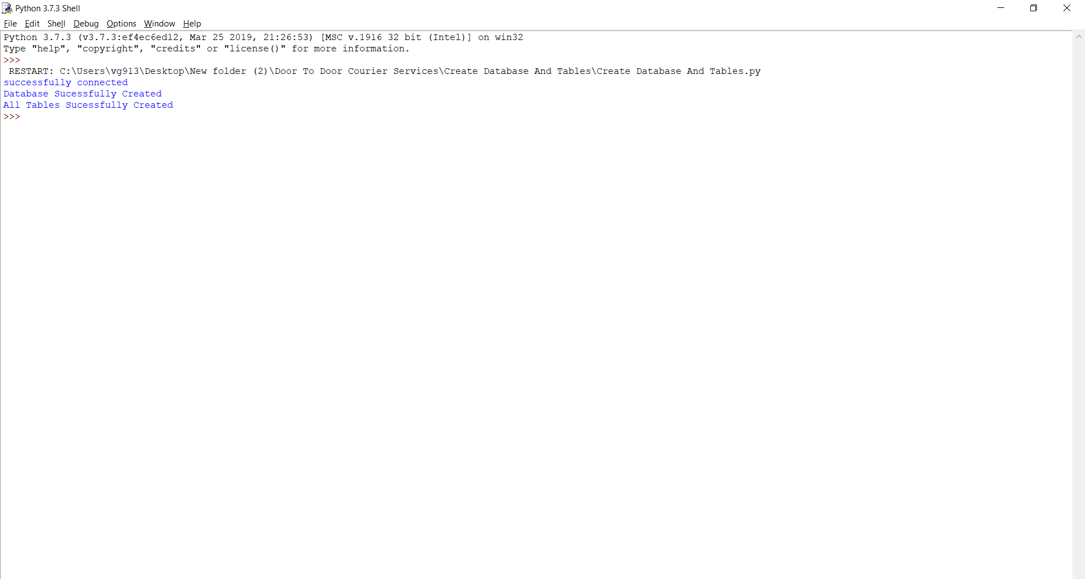

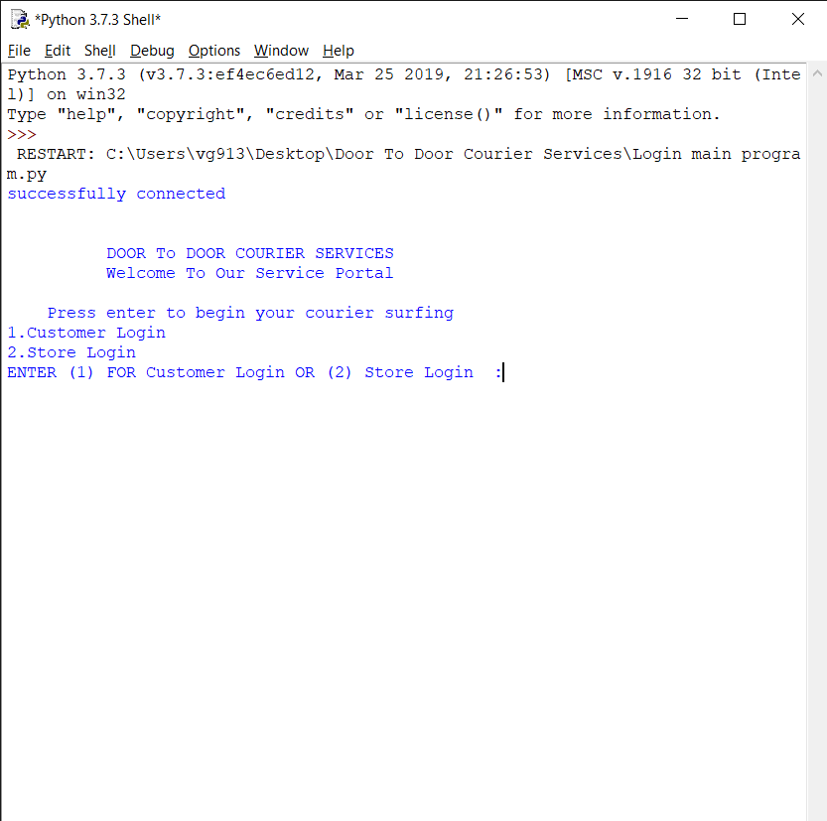

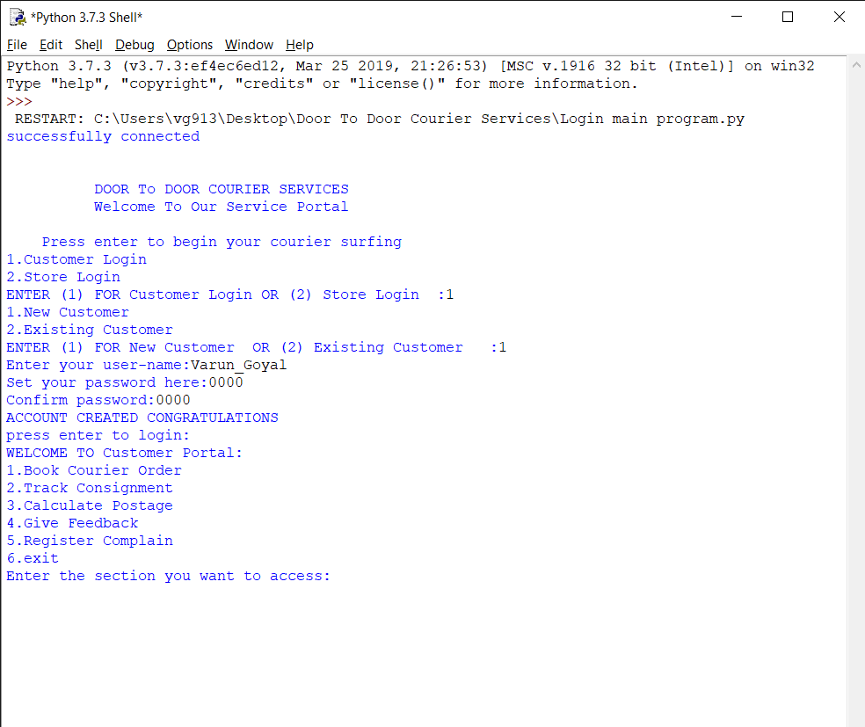

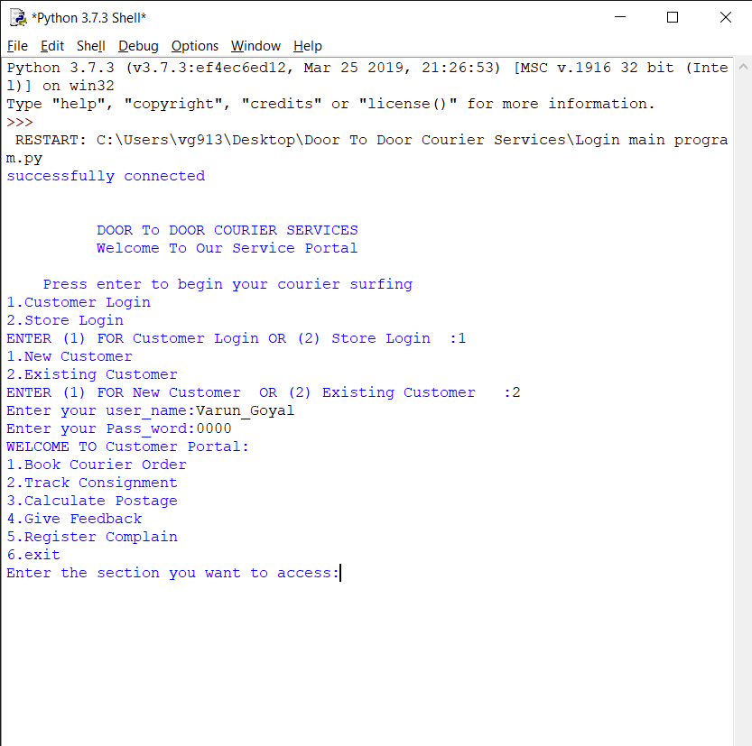

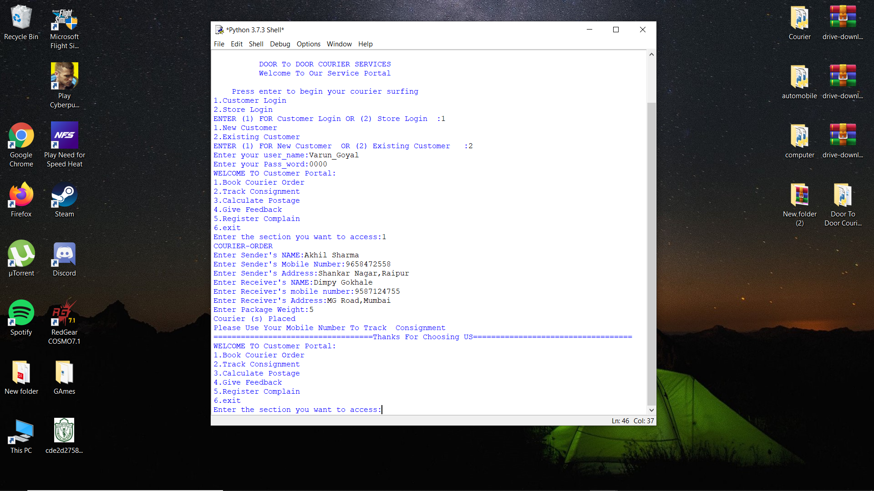

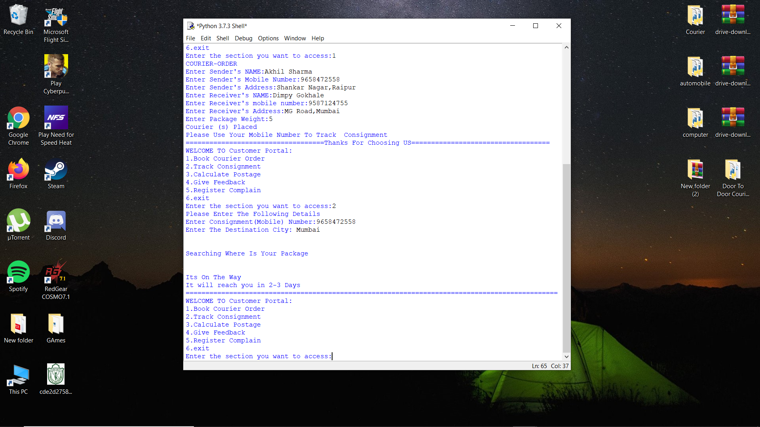

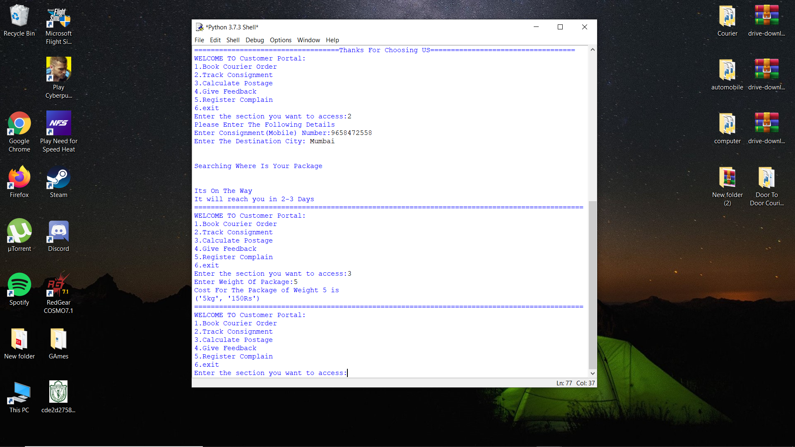

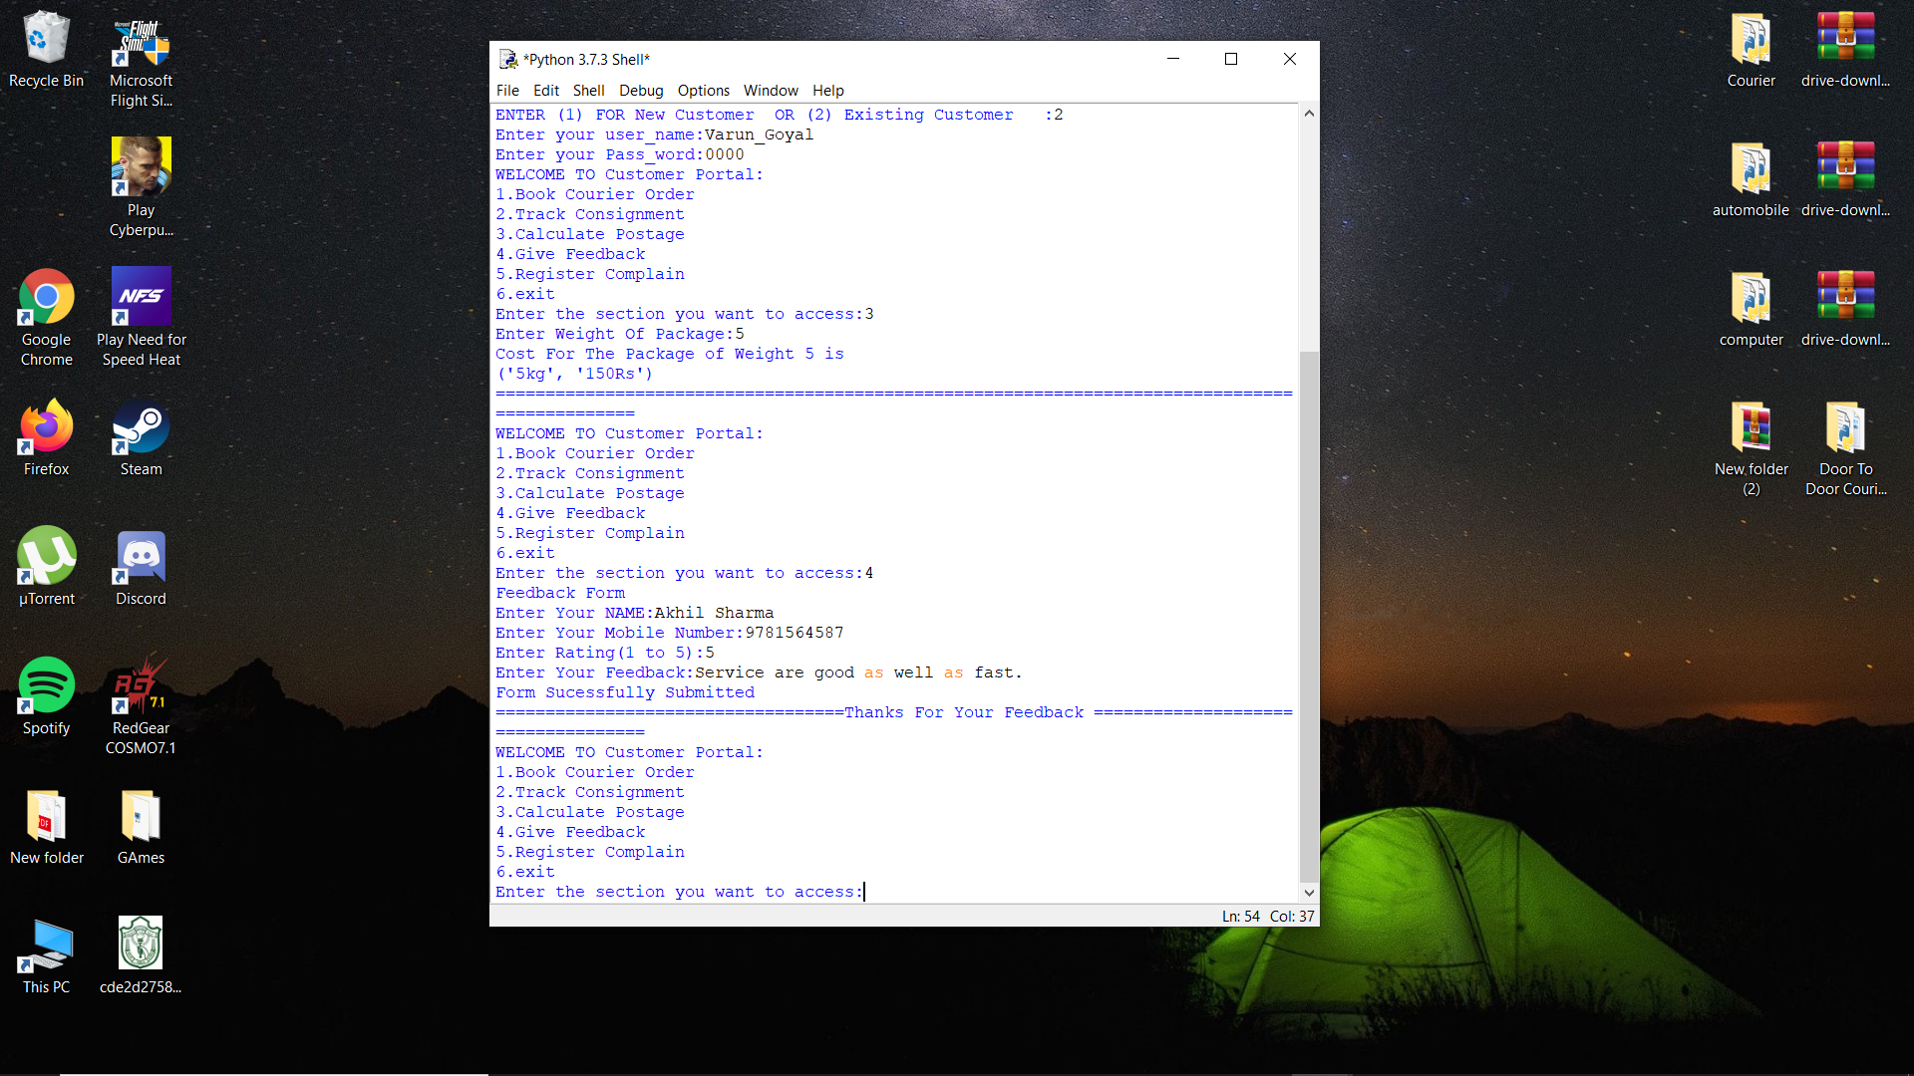

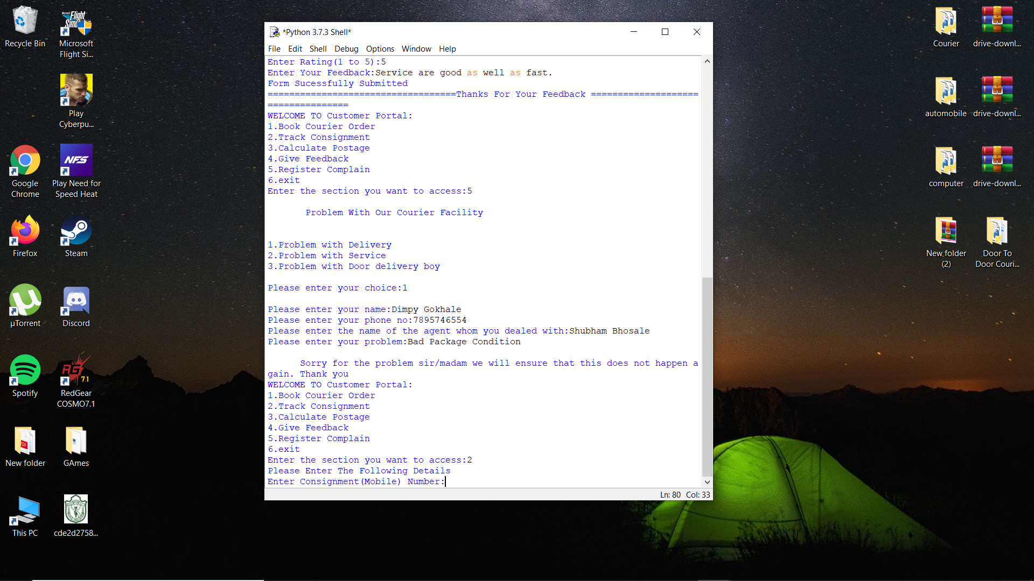

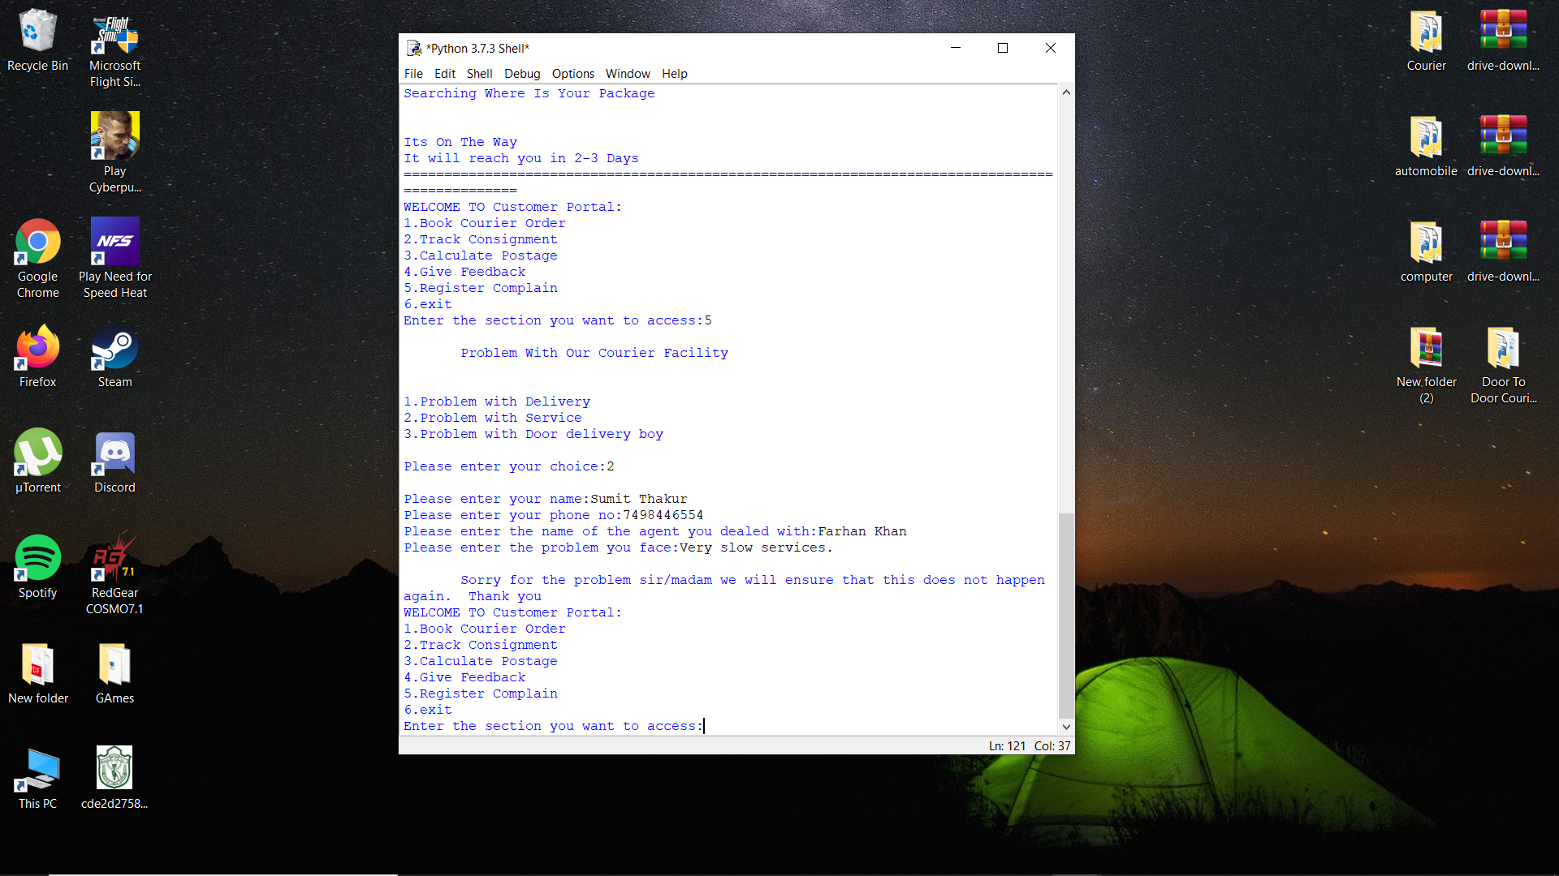

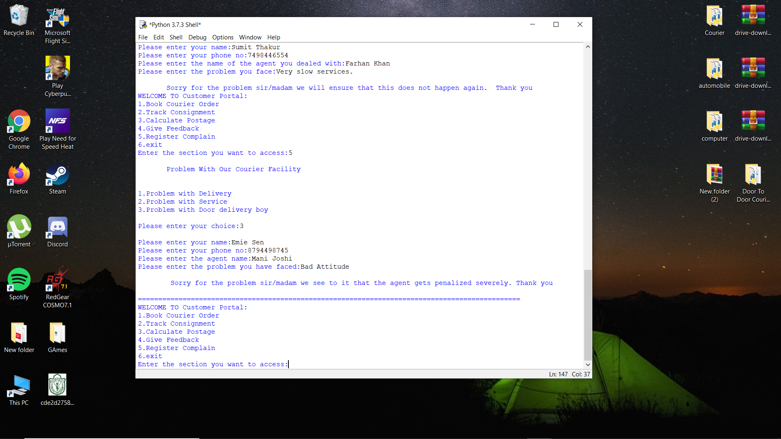

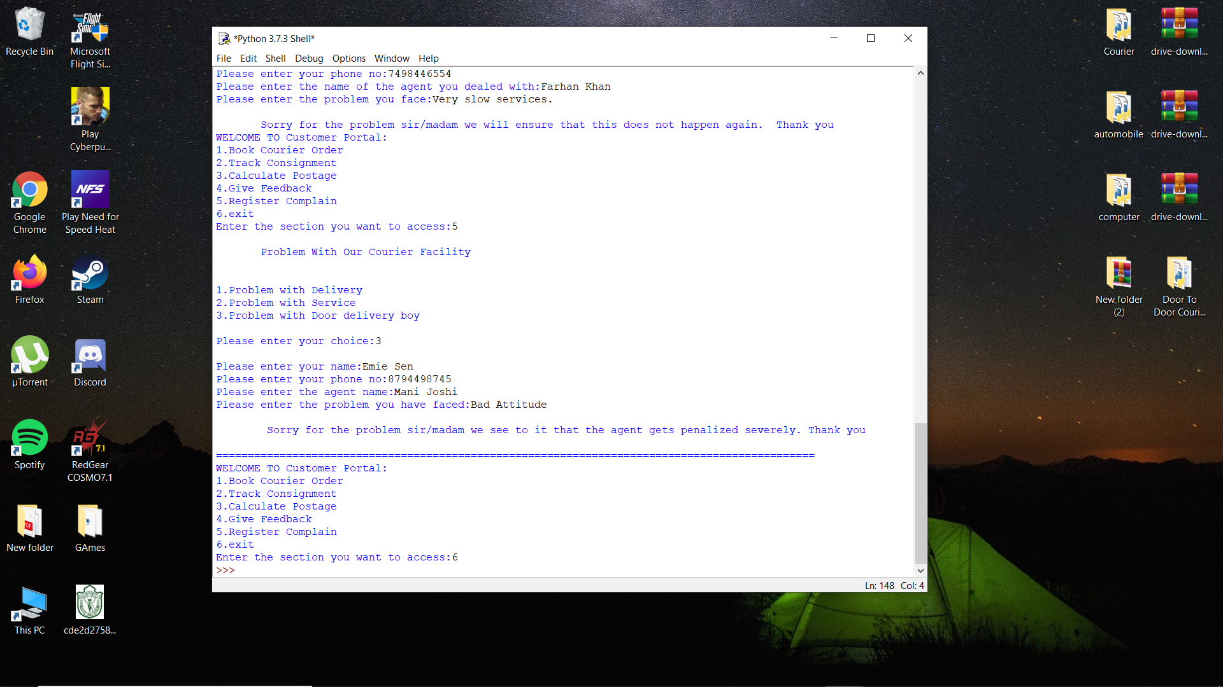

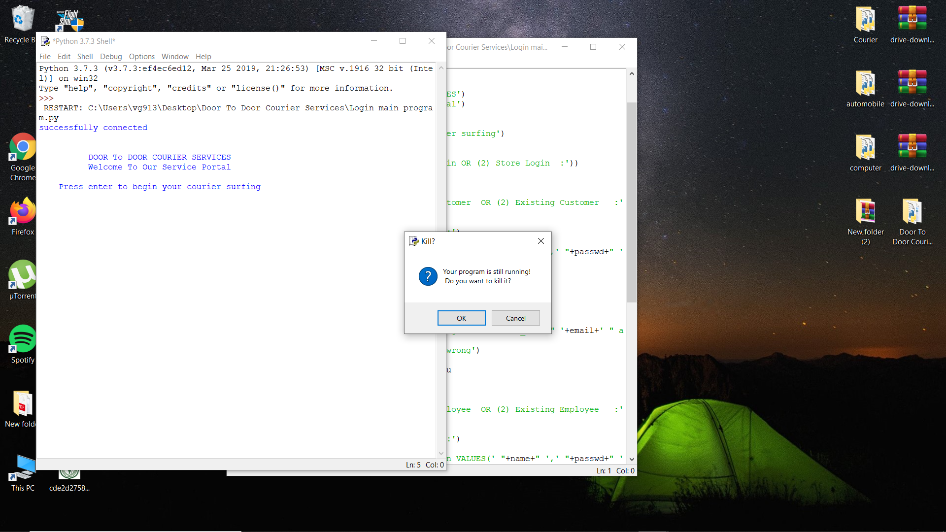

**\*\*\*\*\*\*\*\*\*\*\*\*\*\*\*\*\*\*\*\*\*\*\*\*\*\*\*\*\*\*\*\*\*\*\*\*\*\*\*\*\*\*\*\*\*\*\*\*\*\*\*\*\*\*\*\*\*\*\*\*\*\*\*\*\*\*\*\*\*\*\*\*\*\*\*\*\*\*\*\*\*\*\*\*\*\*\*\*\*\*\*\*\*\*\*\*\*\*\*\*\*\*\*\*\*\*\*\*\*\*\*\*\*\*\*\*\*\*\*\*\*\*\*\*\*\*\*\*\*\*\*\*\*\*\*\*\*\*\*\*\*\*\*\*\*\*\*\*\*\*\*\*\*\*\*\*\*\*\*\*\*\***

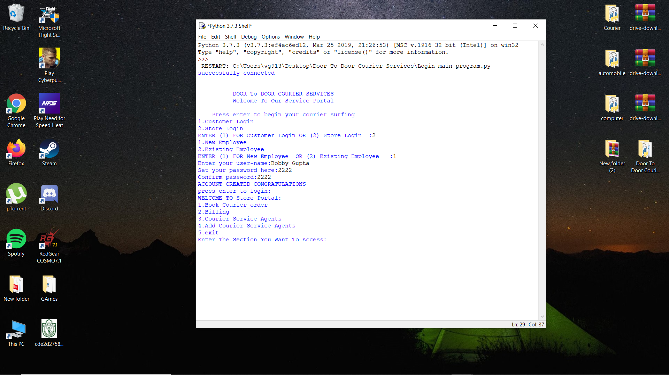

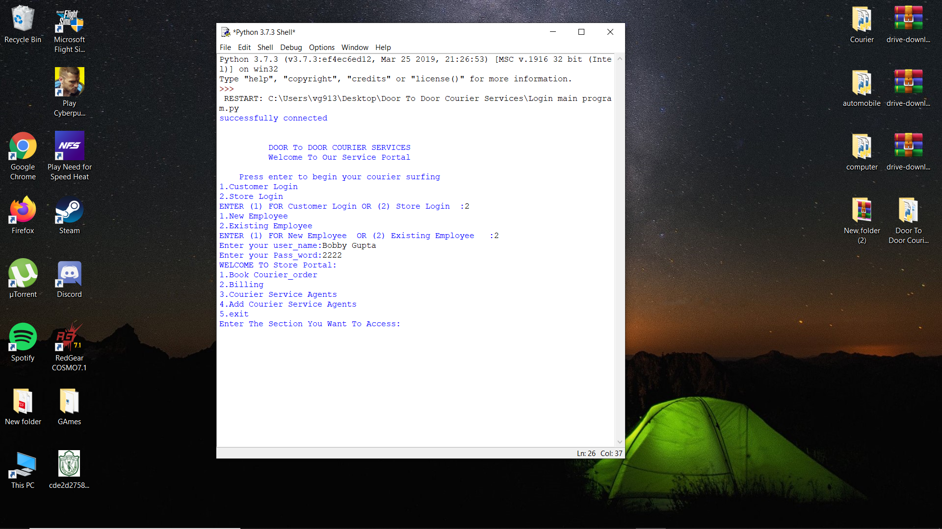

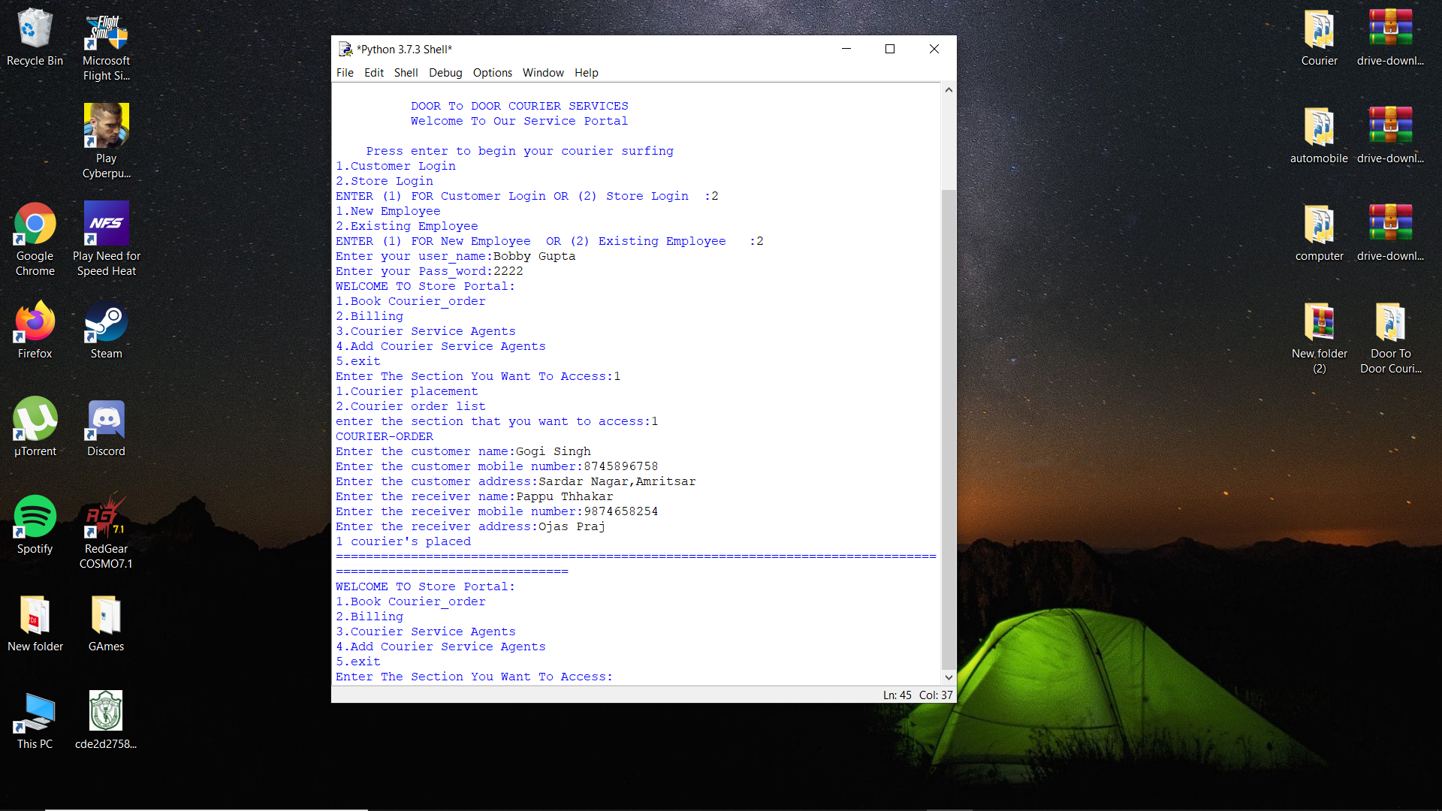

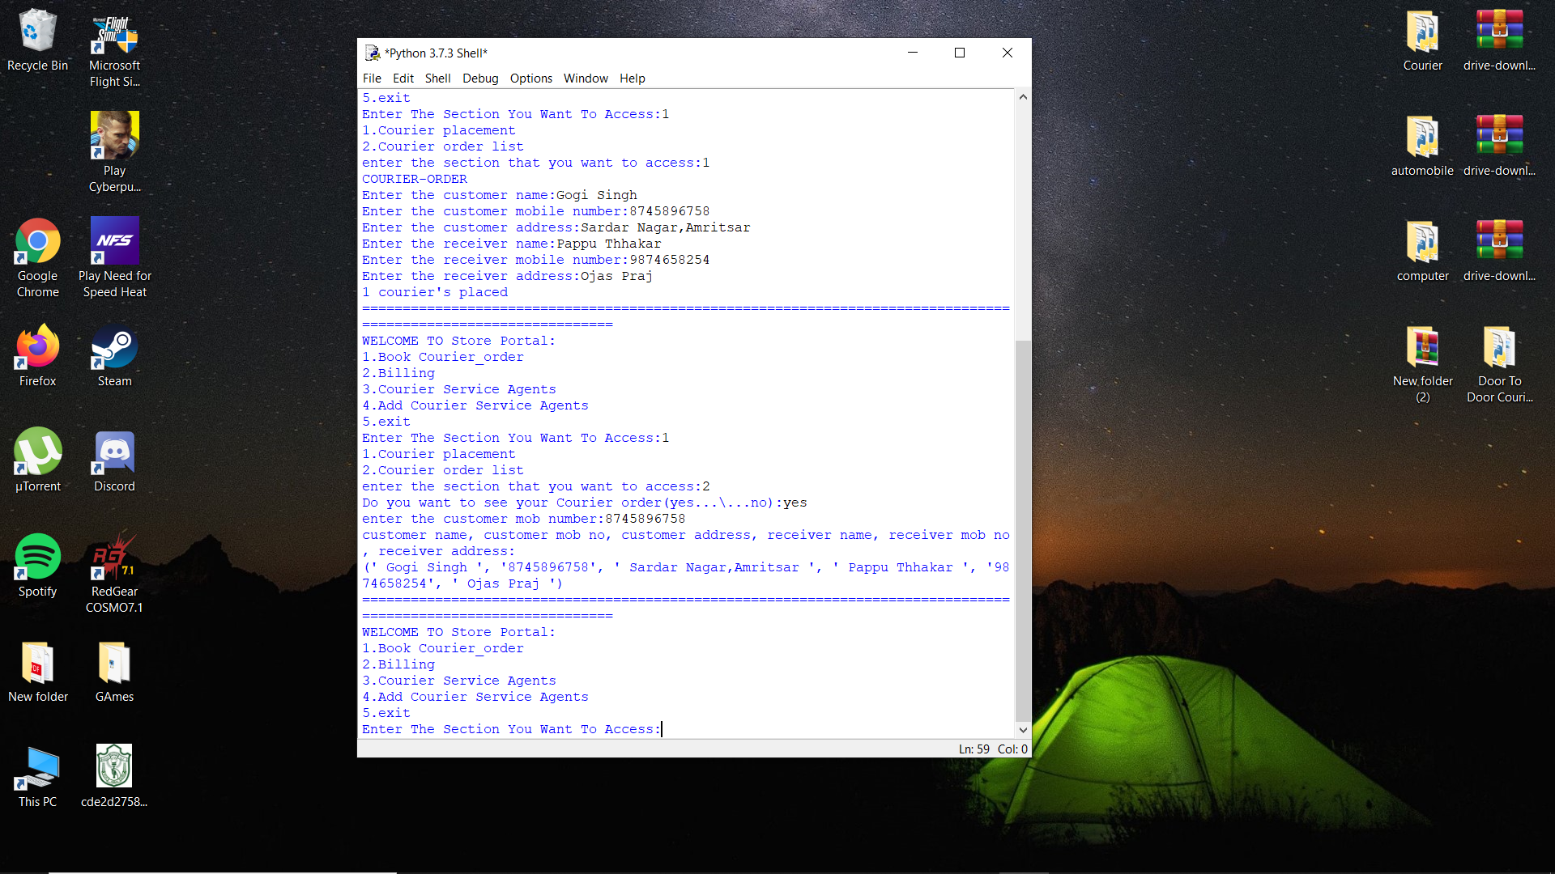

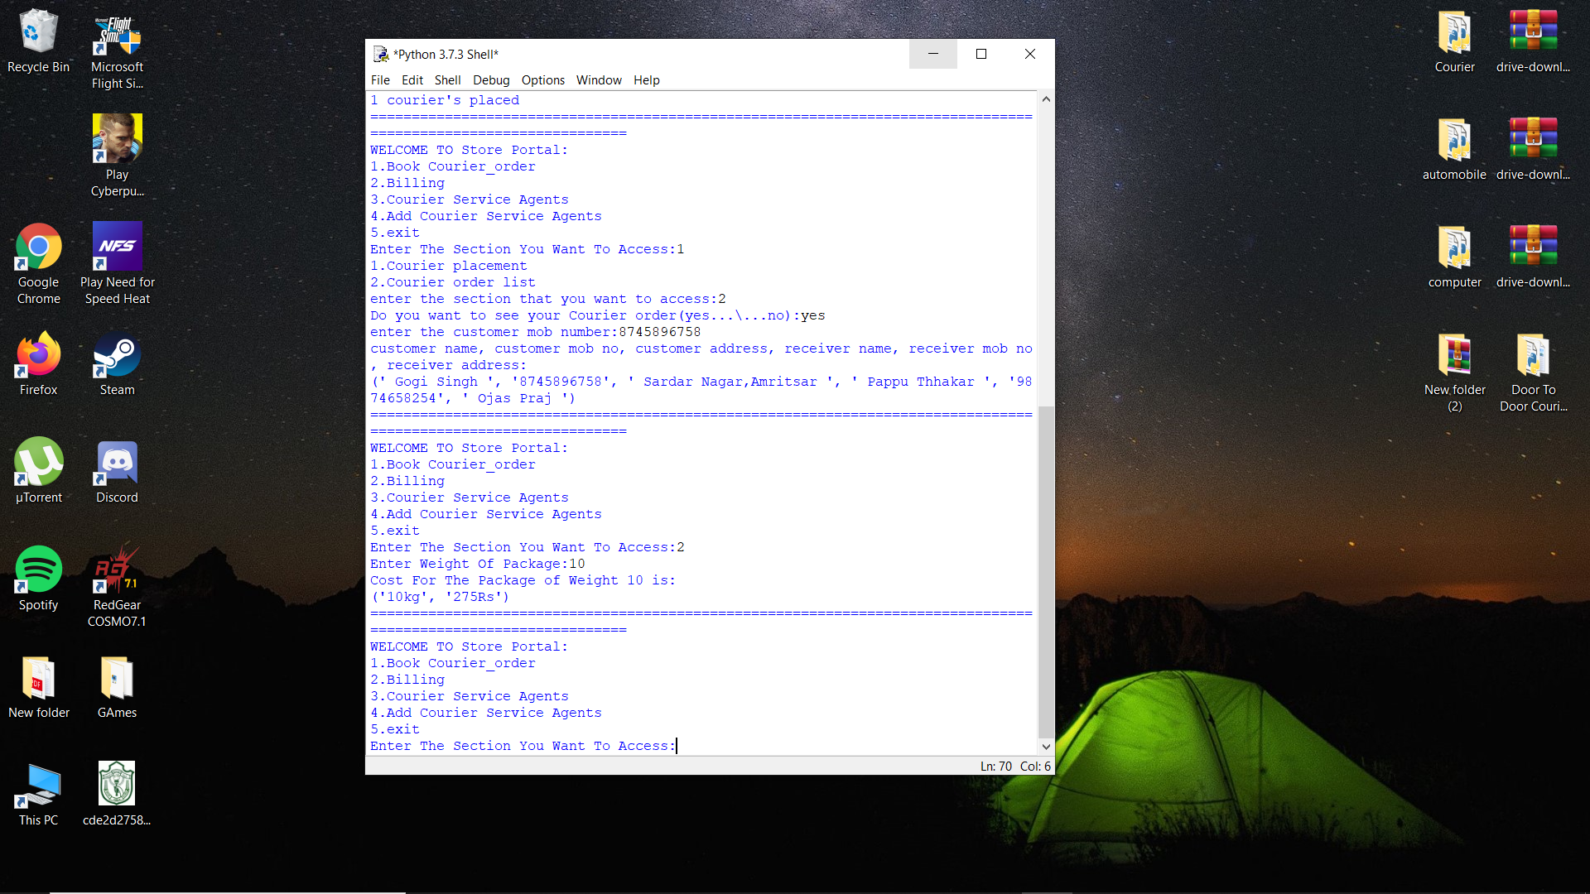

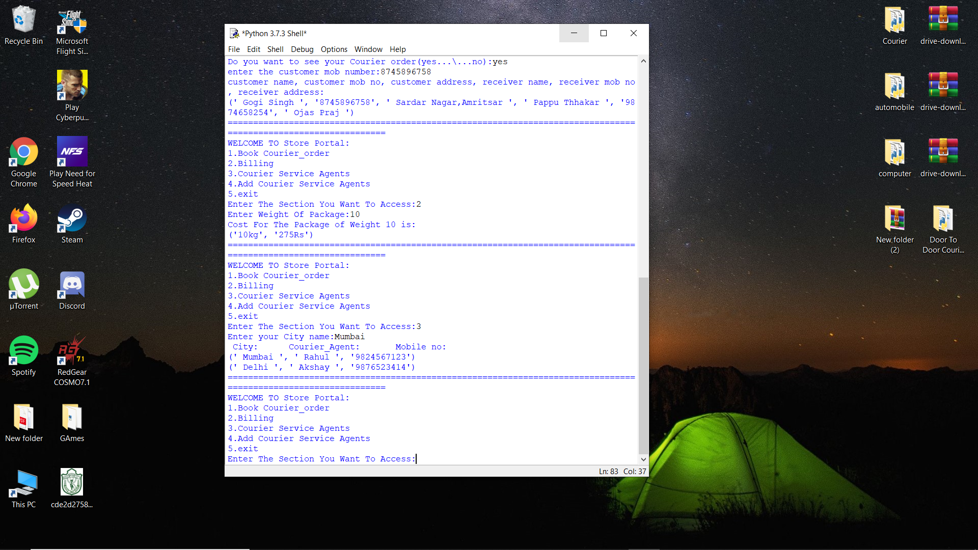

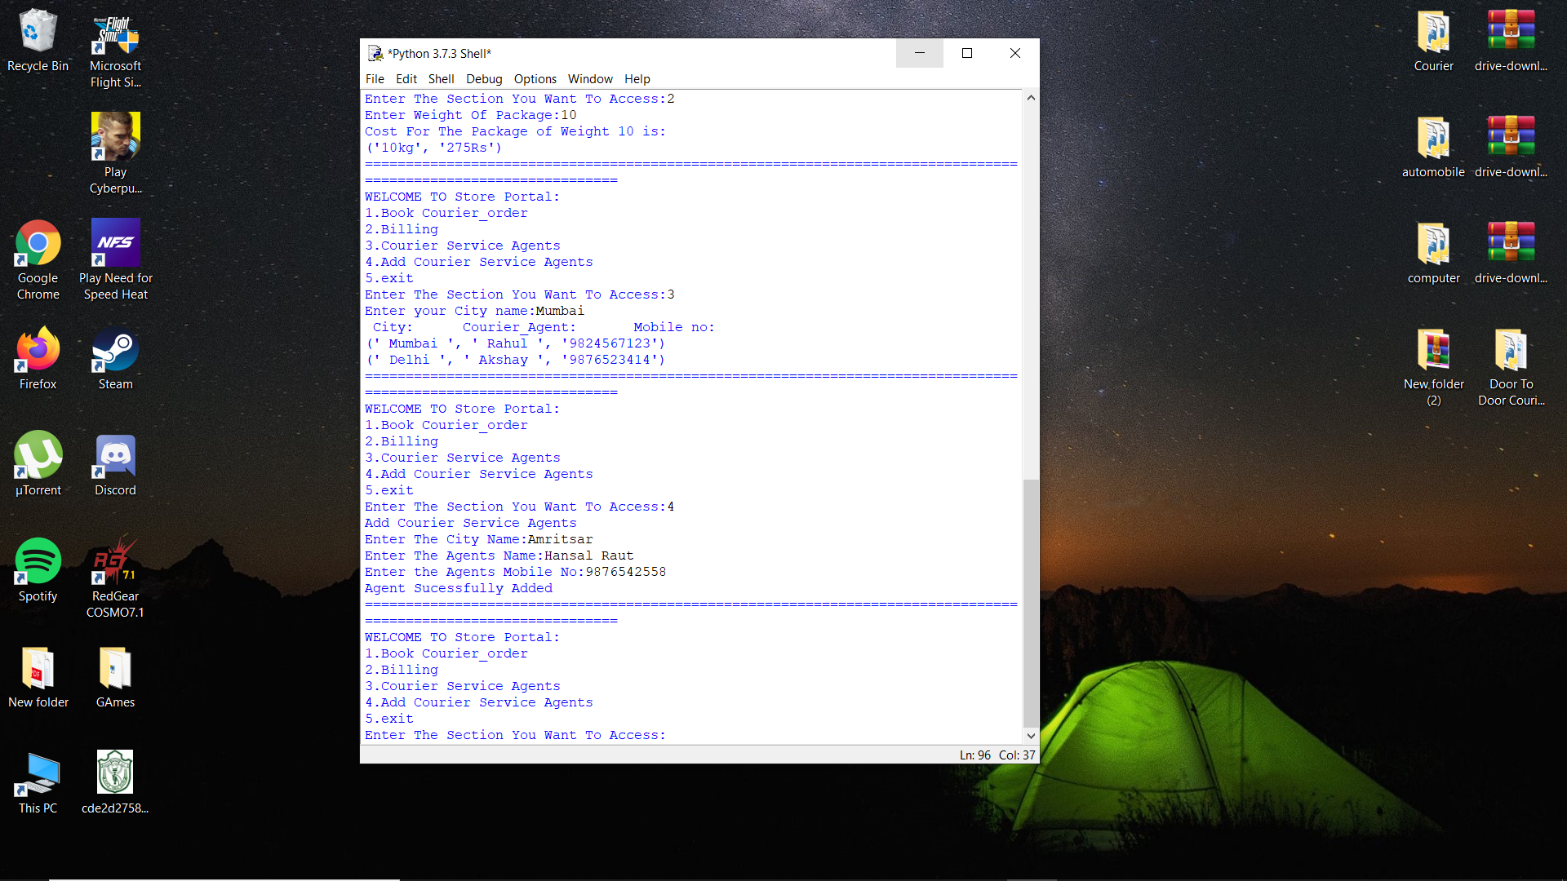

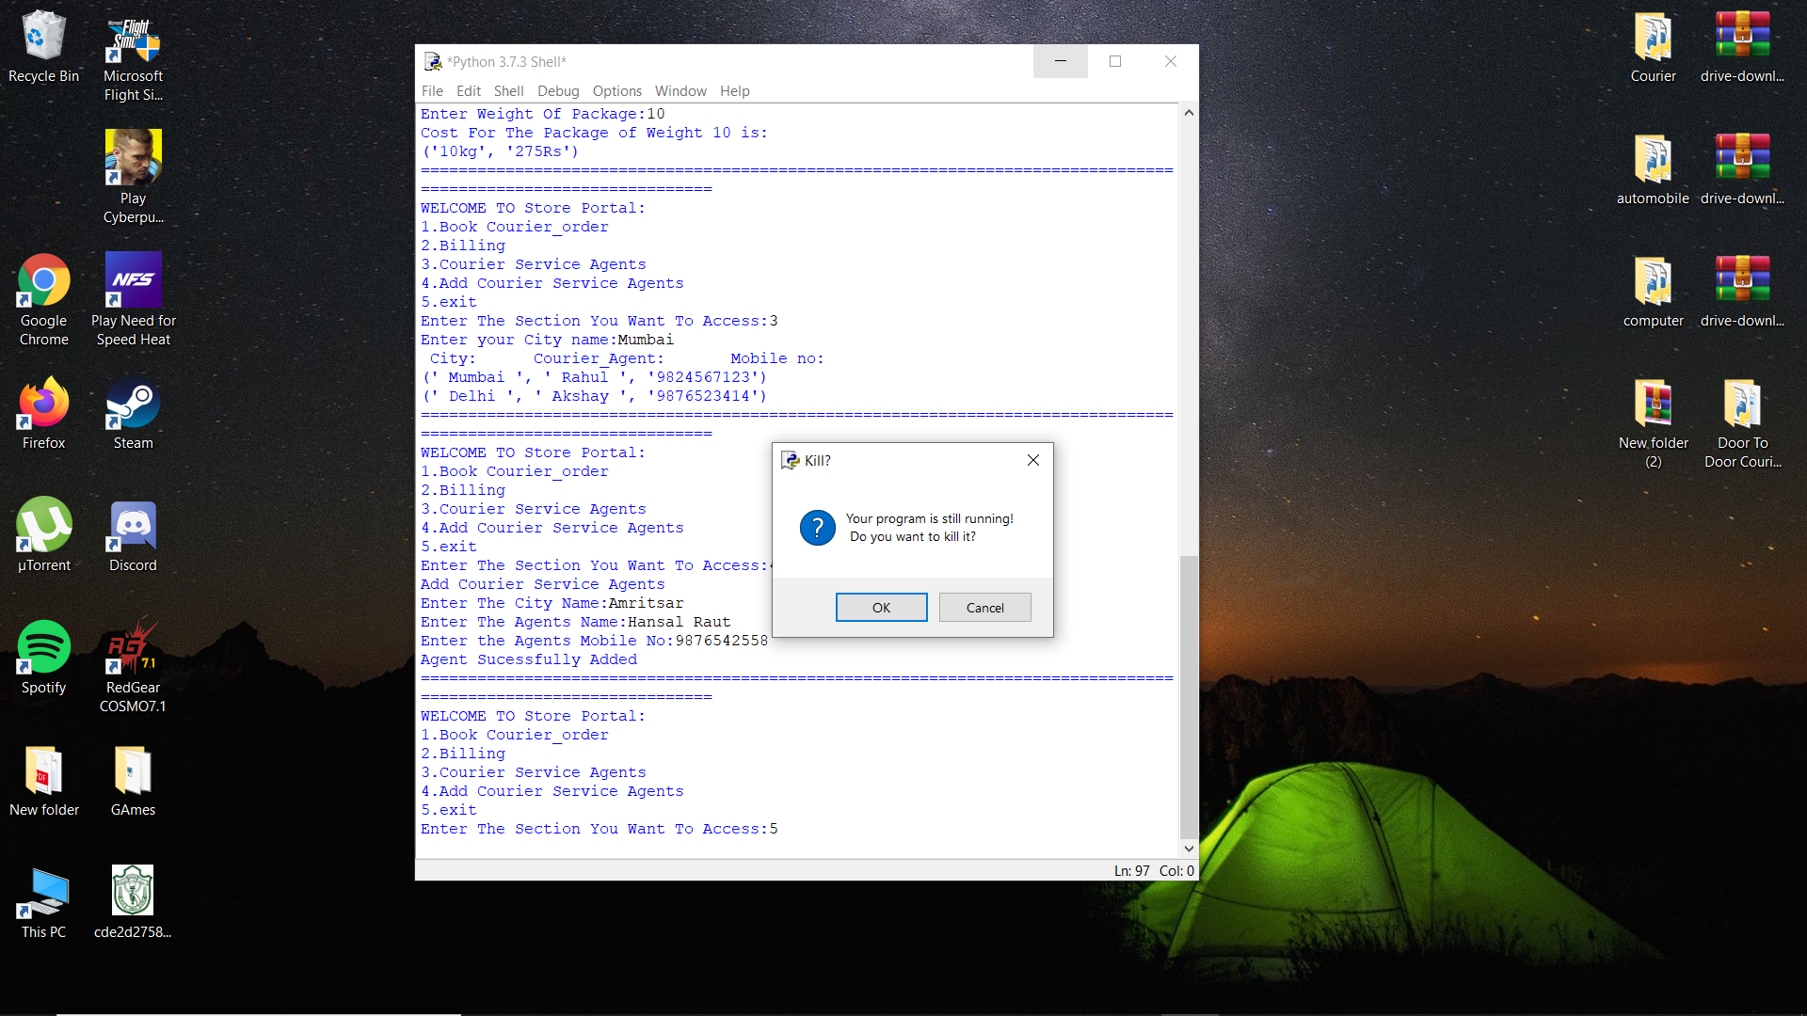********************************************************************************************************************************************************************

**HARDWARE AND SOFTWARE REQUIREMENTS**

I.OPERATING SYSTEM : WINDOWS 7 AND ABOVE

II. PROCESSOR : PENTIUM(ANY) OR AMD

ATHALON(3800+- 4200+ DUAL CORE)

III. MOTHERBOARD : 1.845 OR 915,995 FOR PENTIUM 0R MSI

K9MM-V VIA K8M800+8237R PLUS CHIPSET FOR AMD ATHALON

IV. RAM : 512MB+

V. Hard disk : SATA 40 GB OR ABOVE

VI. CD/DVD r/w multi drive combo: (If back up required)

VII. FLOPPY DRIVE 1.44 MB : (If Backup required)

VIII. MONITOR 14.1 or 15 -17 inch

IX. Key board and mouse

X. Printer : (if print is required – [Hard copy])

SOFTWARE REQUIREMENTS:

I. Windows OS

II. Python

**INSTALLATION PROCEDURE**

**STEP 1:** Open folder Create Database And Tables.

**STEP 2:** Open py file Create Database And Tables.

**STEP 3:** Run the file Create Database And Tables in python idle 3.7.

(Database and all tables Created)

**STEP 4:** Now, Start Login main program TO Access the PROGRAM.......

**Note-** Login main program Imports other to menus--

i.) Customer_Courier_Menu

ii.) Store_Courier_Menu

**BIBLIOGRAPHY**

**Books**

**COMPUTER SCIENCE WITH PYTHON CLASS XiI – BY** SUMITHA ARORA

**Oswaal Question Bank OF Computer Science**

**A Project on Courier Service System**

**Websites**

[**www.stackoverflow.com**](http://www.stackoverflow.com)

[**www.GeeksForGeeks.org**](http://www.GeeksForGeeks.org)

[**www.Programiz.com**](http://www.Programiz.com)

**\*\*\*\*\*\*\*\*\*\*\*\*\*\*\*\*\*\*\*\*\*\*\*\*\*\*\*\*\*\*\*\*\*\*\*\*\*\*\*\*\*\*\*\*\*\*\*\*\*\*\*\*\*\*\*\*\*\*\*\*\*\*\*\*\*\*\*\*\*\*\*\*\*\*\*\*\*\*\*\*\*\*\*\*\*\*\*\*\*\*\*\*\*\*\*\*\*\*\*\*\*\*\*\*\*\*\*\*\*\*\*\*\*\*\*\*\*\*\*\*\*\*\*\*\*\*\*\*\*\*\*\*\*\*\*\*\*\*\*\*\*\*\*\*\*\*\*\*\*\*\*\*\*\*\*\*\*\*\*\*\*\*\*\*\*\*\*\*\*\*\*\*\*\*\*\*\*\*\*\*\*\*\*\*\*\*\*\*\*\*\*\*\*\*\*\*\*\*\*\*\*\*\*\*\*\*\*\*\*\*\*\*\*\*\*\*\*\*\*\*\*\*\*\*\*\*\*\*\*\*\*\*\*\*\*\*\*\*\*\*\*\*\*\*\*\*\*\*\*\*\*\*\*\*\*\*\*\*\*\*\*\*\*\*\*\*\*\*\*\*\*\*\*\*\*\*\*\*\*\*\*\*\*\*\*\*\*\*\*\*\*\*\*\*\*\*\*\*\*\*\*\*\*\*\*\*\*\*\*\*\*\*\*\*\*\***